SETTLEMENT AGREEMENT AND RELEASE OF CLAIMS

This Settlement Agreement is made by and between the parties described below in Section 1.10 and is intended to settle and release all claims in two pending lawsuits subject to the terms and conditions described below and Court approval. The lawsuits are (1) Lehman v. Extra Car Airport Parking, Inc., eta/., No. 14-2-08531-1 KNT, King County Superior Court, and (2) Russell v. Extra Car Airport Parking, Inc., No. 17-2-16394-5 KNT, King County Superior Court.

- DEFINITIONS

  - "Class Counsel" means Adam J. Berger, Lindsay L. Halm, and Jamal N. Whitehead of Schroeter Goldmark & Bender.

  - "Class Members" refers to members of the Lehman Class and Russell Class collectively.

  - "Effective Date" means the later ofthe occurrences described in Section 7.2.

  - "Extra Car" refers to Defendant Extra Car Airport Parking, Inc. in both the Lehman
and Russell cases.

  - The "Lawsuits" refers to the actions captioned as Lehman v. Extra Car Airport Parking, Inc., et a/., No. 14-2-08531-1 KNT, and Russell v. Extra Car Airport Parking, Inc., No. 17-2-16394-5 KNT, both currently pending in King County Superior Court.

  - The "Lehman Case" refers to the case of Lehman v. Extra Car Airport Parking, Inc., eta/., No. 14-2-08531-1 KNT.

  - "Lehman Class" shall mean the Certified Class in the Lehman Case.

  - "Lehman Class Member" shall mean a member of the certified class, who has not opted out, in the Lehman Case.

  - "Lou Lehman," "Lehman," or "Lehman Class Representative" all mean Lou Lehman, the named plaintiff in the Lehman Case.

  - The "Parties," as used in this Agreement, means (1) Plaintiff Lou Lehman, (2) Plaintiff Robert Russell, (3) Defendants Michael Vergillo and Kimberly Edwards­ Vergillo, and (4) Defendant Extra Car Airport Parking, Inc.

1.11. "Robert Russell," "Russell," or "Russell Class Representative" all mean Robert Russell, the named plaintiff in the Russell Case.

1.12. The "Russell Case" refers to Russell v. Extra Car Airport Parking, Inc., No. 17-2- 16394-5 KNT.

"Russell Class" means the settlement class to be certified in the Russell Case in accordance with Section 3, and its subparts, ofthis Agreement.

  - "Russell Class Member" shall mean a member of the putative settlement class to be certified in the Russell Case in accordance with Section 3, and its subparts, of this Agreement.

  - "Settlement Agreement" or "Agreement" means this Settlement Agreement between the Parties.

  - The "Vergillo Defendants" or "Vergillos" refers to Michael Vergillo and Kimberly Edwards-Vergillo, owners ofExtra Car, and named defendants in the Lehman Case.

- RECITALS

This Settlement Agreement is made with reference to the following facts:

  - On or about March 26, 2014, Lou Lehman filed a class action complaint on behalf of herself and all other similarly situated employees against her former employer Extra Car, alleging that Extra Car did not pay the required hourly rate under the SeaTac minimum wage ordinance, SeaTac Municipal Code 7.45. She later amended the complaint to name the Vergillos as defendants.

  - The Court certified the Lehman Case as a class action on or about March 15, 2016, certifying a class of all persons employed by Extra Car as hourly paid employees in nonmanagerial and nonsupervisory capacities, including transport drivers, lot attendants, shuttle drivers, cashiers, and similar positions, who did not opt out of the Lehman Case, at any time from January 1, 2014 through September 10, 2016 ("Lehman Class Period"). A list of Lehman Class Members is set forth in Exhibit A to this Agreement.

  - On or about June 27, 2017, Robert Russell, a former temporary worker assigned by his employer, staffing company Command Center, Inc., to provide temporary labor to Extra Car, filed a class action complaint against Extra Car on behalf of himself and all other similarly situated Command Center workers. Russell alleged, among other things, that Extra Car was his joint employer and failed to pay the required hourly rate under the SeaTac minimum wage ordinance.

  - The complaint in the Russell Case described the putative class as all current and former employees of Command Center, Inc. who worked for Extra Car at any time from August 15, 2014 to the present.

  - The Lawsuits sought (a) damages for minimum wages under Chapter 7.45 of the SeaTac Municipal Code ("Minimum Employment Standards for Hospitality and Transportation Industry Employees"); (b) damages for overtime wages under RCW 49.46.130; (c) exemplary damages pursuant to RCW 49.52.070; (d) attorneys' fees and costs; and (e) prejudgment interest.

  - Extra Car and the Vergillos deny liability for any and all claims stated in the Lawsuits.

  - The Parties have engaged in comprehensive settlement discussions. It is the mutual desire of the Parties to fully, finally, and forever settle, compromise, and discharge all disputes and claims that have been alleged in the Lawsuits or that arise out of or could have been alleged on the basis of the facts and circumstances alleged in the Lawsuits, including federal, state, municipal, and contractual claims.

- RUSSELL CLASS CERTIFICATION

  - The Parties agree that Russell will move the Court for certification of a settlement class in the Russell Case under CR 23(b)(3) solely for purposes of effectuating this Settlement Agreement and conditioned on final approval of the Settlement by the Court. As part of this motion, Russell will ask the Court to designate him as the representative of the settlement class, and to appoint Adam J. Berger, Lindsay L. Halm, and Jamal N. Whitehead of Schroeter Goldmark & Bender as Class Counsel for the settlement class. Extra Car agrees not to oppose Russell's motion to certify a settlement class.

  - The putative settlement class, or Russell Class, shall include all past and present employees of Command Center, Inc. who provided temporary labor to Extra Car in SeaTac from August 15, 2014 through July 27, 2016 (the "Russell Class Period"), who do not opt out ofthe Russell Case. The list of potential Russell Class Members is set forth in Exhibit B to this Settlement Agreement.

  - Except as provided in Paragraph 3.1 above, Defendants do not waive their right to contest or object to the certification of any class in the Russell Case for any other purposes in the event that this Settlement Agreement shall be vacated or become void for any reason.

- SETTLEMENT FUND & PAYMENT REQUIREMENTS

  - The Settlement Fund. Defendants shall establish a fund of $500,000 (Five Hundred Thousand Dollars), which shall be referred to herein as the "Settlement Fund." This fund is inclusive of all of Defendants' financial obligations under this Settlement Agreement (including all obligations for attorneys' fees and litigation costs, costs of notice, any Incentive Payment to the Lehman Class and Russell Class Representatives, the employees' normal portions of payroll taxes on the settlement
payments, and the costs of settlement administration), except as otherwise specifically provided in Section 5.6.

  - Installments. Defendants shall fund the Settlement Fund over four (4) installments in the amounts described below. For each installment, Defendants shall deliver checks made out to Class Members or to Class Counsel in amounts provided by Class Counsel to Defendants with the aggregate amounts of such checks equaling the amounts of the installments listed below. Defendants shall make the following installment payments:

    - $175,000 to be paid within 15 business days ofthe Effective Date ofthis Agreement,

    - $75,000 within six months of the first installment described above in Section

4.2.1,

    - $125,000 within one year ofthe second installment described above in Section
4.2.2, and

    - $125,000 within one year ofthe third installment described above in Section

4.2.3.

  - Payment Requirements. Defendants agree to make timely installment payments as set forth above in Section 4.2 and its subparts. If any payment is late, Class Counsel agrees to give Defendants written notice of the late payment by sending such notice to Defendants' attorneys, Douglas Smith and Breanne Martell. If payment is not made within 14 calendar days of receipt ofthe notice, Class Counsel shall be entitled to enter the Confession of Judgement, which is attached to this Agreement as Exhibit C, without further notice. Upon entry of the Confession of Judgment, Class Counsel
shall have the right to immediately pursue collection of the judgment against Defendants by exercising all remedies available to Plaintiffs under the law, including attorneys' fees and costs in pursuing the judgment. Defendants agree to execute this Confession of Judgement at the same time this Agreement is signed, and agree the executed Confession of Judgment shall be held in escrow by Class Counsel and destroyed immediately after all payments by Defendants have been made. Class Counsel shall provide written confirmation that the Confession of Judgment has been destroyed within 14 calendar days of destruction. If any payment is more than one month late, the amount owed on any such payment shall be increased by 1% per month beginning 30 days after its due date. If, however, Plaintiffs do accept one or more late payments, such acceptance shall not be construed to be a waiver, express or implied, of their right to require prompt future payments without further notice. Defendants have the right to prepay the full amount due at any time.

PAYMENTS OUT OF THE SETTLEMENT FUND

  - Net Settlement Fund. The "Net Settlement Fund" is defined as the Settlement Fund less any Incentive Payments to Lehman and Russell as Class Representatives approved by the Court and any award of attorneys' fees and costs to Class Counsel approved by the Court.

  - Division ofNet Settlement Fund. The Net Settlement Fund will be allocated among Class Members based on pro rata percentages ofthe Net Settlement Fund taking into account each person's individual damages as a portion ofthe overall damages as calculated by Class Counsel or their retained expert. These calculations will allocate monies between backpay and interest payments. Class Counsel will make the required calculations, which will be provided to Defendants for review at least 30 days before each installment payment is due. Defendants will provide Class Counsel with any

additional payroll records and other information as may be reasonably necessary to make the required calculations. To the extent that information is needed from Command Center, Inc., Defendants agree to cooperate in requesting such information from Command Center. Defendants' ability to make payments to the Russell Class Members is contingent upon receipt of Social Security Numbers from Command Center. If Defendants' informal requests are unsuccessful, Class Counsel agrees to subpoena Command Center for this information. If Class Counsel is unable to obtain the Social Security Numbers for the Russell Class Members, Defendants shall make the payments due to the Russell Class Members directly to Class Counsel at the time such payments are due; Class Counsel shall then either make payments directly to the Russell Class Members in the amounts calculated by Class Counsel and submitted for review to Defendants or shall petition the Court for further guidance and authorization.

  - Sequence ofPayments. The installment payments described in Section 4.2 above shall be distributed in the following manner:

    - The first set of payments will be made to the Lehman Class Members. Any Incentive Payment to Lehman is also to be paid at this time.

    - The second set of payments will be made to the Lehman Class Members. To the extent there are funds remaining from the second installment, those funds may be used to pay either the Russell Incentive Payment and/or a portion of Class Counsel's cost award.

    - The third set of payments will be made to the Russell Class Members and to the Lehman Class Members to the extent that any Lehman Class Members have not previously received their full pro rata share of the Net Settlement Fund. Any Incentive Payment to Russell is also to be paid at this time to the extent payment has not already been made as provided in Section 5.3.2 above. Any remaining monies will be used to pay Class Counsel's attorneys' fees and costs, as approved by the Court.

    - The fourth set of payments will be used to pay the remainder of Class Counsel's attorneys' fees and costs, as approved by the Court, with any funds remaining thereafter to be treated as Residual Funds as described below in Section 5.8.

    - Class Counsel will make reasonable efforts to reduce the number of checks to be issued, while still ensuring an equitable distribution.

  - Attorneys' Fees and Costs. Class Counsel will apply to the Court for payment from the Settlement Fund of attorneys' fees and reasonable litigation costs of an amount that does not exceed one-third (33.33%) of the Settlement Fund. Defendants will not oppose the request to the extent the fee and cost request does not exceed one-third (33.33%) ofthe Settlement Fund. The attorneys' fees and litigation costs actually paid from the Settlement Fund shall be that amount approved by the Court. The

enforceability of this Settlement Agreement is not contingent on the amount of attorneys' fees or litigation costs awarded, and any dispute regarding the amount of attorneys' fees or litigation costs, and/or any appeal related thereto, shall not affect or delay the finality of this Settlement Agreement, and shall not affect or delay the entry of dismissal of the Lawsuits with prejudice.

  - Incentive Payments to Class Representatives. The Parties agree that Class Counsel will request payments from the Settlement Fund to Lehman in the amount of$7,500 (Seven Thousand Five Hundred Dollars) and to Russell in the amount of$2,000 (Two Thousand Dollars) for their roles and efforts as named plaintiffs in the Lawsuits ("Incentive Payments"). Any Incentive Payments shall be subject to Court approval. These amounts shall be in addition to Lehman's and Russell's pro rata shares of the Net Settlement Fund. The enforceability of this Agreement is not contingent on the amount of the Incentive Payments (if any) that are granted by the Court.

  - Tax Allocation. As described in Section 5.2 above, the awards to individual Lehman Class Members shall be divided between backpay and prejudgment interest. At their option, Defendants shall issue either: (i) separate checks to each Lehman Class Member for backpay settlement awards and interest in the amounts calculated pursuant to Section 5.2 above; or (ii) a single check with a stub separately identifying the backpay and interest amounts. The amounts allocated as interest shall not be treated as wages and shall not be subject to payroll taxes. The amounts allocated as backpay settlement awards for the Lehman Class Members shall be treated as wages and subject to payroll taxes, and Defendants shall pay the employer's portion of payroll taxes on that portion ofthe Lehman Class Members' settlement payments that is treated as wages. Defendants' payment ofthe employer's portion of payroll taxes shall be in addition to, and shall not come out of, the Settlement Fund. All amounts paid to the Russell Class Members shall be designated as "Other Income" on IRS Form 1099-MISC. The Russell Class Members assume full responsibility and liability for the payment of any taxes or other amounts that may be due as a result of payment. Except for the employer's portion of payroll taxes on payments treated as wages to Lehman Class Members, Defendants shall have no responsibility or liability for any federal or state taxes owed in connection with the payments made under this Settlement Agreement.

  - Tax Reporting. Defendants shall prepare and provide to each Lehman Class Member receiving a settlement payment from the Net Settlement Fund a Form W-2 (for the portion of their settlement payment allocated to wages) and a Form 1099 (for the portion of their settlement payment allocated to interest) for such settlement awards. Defendants shall prepare and provide to each Russell Class Member a Form 1099 ("Other Income"). Lehman and Russell will also receive a Form 1099-MISC for any Incentive Payment they receive (designated as "Other Income"). Class Counsel will receive a Form 1099 for the attorneys' fees and litigation costs awarded to Class Counsel. The Parties agree that the attorneys' fees and litigation costs awarded to Class Counsel need not be reported to the IRS as being income to the Class Members, based on the analysis in Internal Revenue Service Office of Chief Counsel Memorandum PREN0-111606-07 (May 18, 2007). Any required tax forms not

provided to Class Counsel contemporaneously with the settlement checks shall be mailed by Defendants directly to the affected member ofthe Class.

  - Residual Funds. In accordance with CR 23(f), all settlement payments to the Class Members that cannot be delivered and/or are not cashed within 120 calendar days after their issuance by Defendants shall be carried over, added to the aggregate amount of the next installment payment, and allocated pro rata among the remaining Lehman Class Members. Any settlement payments made to the Class Members as part of the fourth installment payment that cannot be delivered and/or are not cashed within 120 calendar days after their issuance by Defendants shall be paid 50 percent to the Fair Work Center and 50 percent to the Legal Foundation of Washington.
Within thirty (30) calendar days after the end of each 120-day period, Defendants will advise Class Counsel in writing of the amounts of such uncashed settlement checks. Defendants will issue and deliver checks to the Fair Work Center and the Legal Foundation of Washington as provided above no later than two hundred and ten (210) calendar days after the due date of the fourth installment payment and shall notify Class Counsel of such delivery. The enforceability ofthis Settlement Agreement is not contingent on Court approval of the designated recipients of the Residual Funds, and shall not affect or delay the finality of this Settlement Agreement.

TIMELINE AND DUTIES OF THE PARTIES BEFORE OBTAINING COURT APPROVAL

  - Lehman and Russell shall move the Court for entry of an order certifying the Russell Class consistent with Section 3 above, preliminarily approving this Settlement, and approving the Notice to the Class Members in each case in the form appended as Exhibit D or Exhibit E to this Agreement no later than thirty (30) calendar days after the execution of this Settlement Agreement. Class Counsel shall provide Defendants with a draft of the motion for preliminary approval at least seven (7) calendar days before the motion for preliminary approval is filed.

  - Notice.

    - The Notice, in a form approved by the Court, shall be sent by Class Counsel
to the Class Members, by first class mail, within thirty (30) calendar days after entry ofthe order of preliminary settlement approval by the Court.

    - Class Counsel acknowledges that Defendants have already provided an address list for the Lehman Class Members, and that Class Counsel has already obtained an address list of the Russell Class Members. Defendants agree, however, to provide updated address information to the extent practicable and to cooperate with Class Counsel in obtaining updated address information for Russell Class Members from Command Center. Class Counsel will use reasonable means to perform an address updating check for Class Members prior to mailing the Notice and to ensure, to the extent practicable,

that the Notice is sent to all Class Members. Class Counsel may also use similar reasonable means to locate the proper address of any Class Member whose Notice is returned as undeliverable.

  - Russell Class Opt Outs.

    - Russell Class Members will have thirty (30) calendar days from the date on the Notice (which date shall be the date three (3) days after the date the Notice is mailed) to opt out of the Russell Class.

    - Any putative Russell Class Member may elect to be excluded from this litigation during the 30-day period after the date of the Notice. To be effective, any such election must be made in writing; must contain the information specified in the Notice; and must be mailed to Class Counsel and postmarked on or before the 30th day after the date ofthe Notice. The date of the postmark on the mailing envelope shall be the exclusive means to determine whether a request for exclusion is timely. Any putative Russell Class Member who is eligible to opt out and who timely requests exclusion in compliance with these requirements shall thereafter not be considered to be a Russell Class Member, shall not have any rights under this Settlement Agreement, shall not be entitled to receive any settlement payment, and shall
not be bound by this Settlement Agreement or any judgment(s) in the Lawsuit.

  - Objections by Class Members; Binding Effect.

    - Lehman Class Members and Russell Class Members will have thirty (30) calendar days from the date on the Notice (which date shall be the date three
(3) days after the date the Notice is mailed) to object to the Settlement Agreement.

    - Except for those Class Members who previously excluded themselves from the Lehman Class, or those who opted out of the Russell Class, all Class Members will be deemed to be members of the Lehman and Russell Classes for all purposes under this Settlement Agreement, the final approval order, the judgment, and the releases set forth in this Settlement Agreement.

    - Any Class Member may object to this Settlement Agreement, provided that such objections are made in writing, contain the information specified in the Notice, and are filed with the Court and served on Class Counsel and counsel for Defendants no later than 30 days after the date of the Notice.

    - Neither Lehman, Russell, Class Counsel, Defendants, Defendants' counsel, nor any person acting on their behalf, shall solicit or otherwise encourage anyone to (a) object to the Settlement Agreement, (b) opt out of the Settlement, (c) appeal from any order ofthe Court that is consistent with the terms of this Settlement Agreement, or (d) discourage participation in the Settlement.

    - Upon receipt, counsel for the Parties shall promptly exchange with one another copies of all objections and/or challenges to the Settlement or any part thereof.

TIMELINE AND DUTIES OF THE PARTIES FOLLOWING NOTICE

  - Lehman and Russell shall move the Court for entry of an Order granting final approval to this Settlement promptly following the objection deadlines in the Russell and Lehman Cases. Class Counsel shall provide Defendants with a draft of the motion and proposed order of dismissal of the Lawsuits with prejudice at least seven (7) calendar days before filing.

  - The settlement embodied in this Settlement Agreement shall become effective on the Effective Date, which is defined as the later of: (i) thirty-one (31) days after entry of the Court's final approval of this Settlement Agreement, if no appeal of that order is filed, or (ii) the date the Court's approval of this Settlement Agreement becomes final and binding after final resolution of any appeals.

  - Class Counsel shall provide the allocations for each individual Class Member's settlement payment to Defendants' Counsel at least 30 days before the first installment payment is due. Defendants shall deliver the first installment payments described above in Section 4.2 to Class Counsel within 15 business days after the Effective Date.

  - Class Counsel shall mail the first round of payments as described in Section 5.3.1 no later than thirty (30) calendar days after receipt of the first installment payment from Defendants described in Section 4.2.

  - Thereafter, Class Counsel shall provide the allocations for each individual Class Member's settlement payment to Defendants' Counsel at least 30 days before the each installment payment is due. Defendants shall deliver the second, third, and
fourth installment payments in accordance with the deadlines described in Section 4.2 above, and Class Counsel shall mail the payments within thirty (30) calendar days after receipt from Defendants.

  - If any Class Members do not cash their checks within 120 days after issuance, their checks will be void. In such event and unless good cause exists to do otherwise, those Class Members will be deemed to have irrevocably waived any right in or claim to a settlement payment or share under this Settlement Agreement, but the Settlement Agreement and the Court's final approval thereof, and the dismissal of the Lawsuits with prejudice, shall nevertheless be binding upon them. Any failure of a Class Member to cash a check shall not affect the enforceability of the releases set forth in this Settlement Agreement, as the Parties jointly agree that valid consideration for same is the offer of monetary consideration by means of the offer of settlement and mailing of settlement checks.

  - The order of dismissal with prejudice of the Lawsuits shall be presented for entry upon entry of the Court's final approval of this Settlement Agreement.

RELEASES BY CLASS MEMBERS AND PLAINTIFFS

  - Upon the Court's final approval ofthis Settlement Agreement (and except as to such rights or claims as may be created by this Settlement Agreement), Plaintiffs Lehman and Russell, and all members of the Lehman Class and the Russell Class, shall be deemed to have knowingly, voluntarily, and completely released and waived all claims arising during the respective class periods, both known and unknown, that have been alleged in the Lawsuits or that arise out of or could have been alleged on the basis of the facts and circumstances alleged in the Lawsuits, including but not limited to federal, state, municipal, and contractual claims, any claims for wages under Chapter 7.45 of the SeaTac Municipal Code, any claims for overtime damages under RCW 49.46.090 or 49.46.130, any claims for exemplary damages pursuant to RCW 49.52.070, and any claims for attorneys' fees, costs, and prejudgment interest relating to the foregoing. The foregoing release and waiver shall be in favor of Extra Car and the Vergillos, together with their parents, subsidiaries, sister companies, affiliates, or subcontractors (however denominated), together with each of their respective predecessors, successors, insurers, officers, directors, partners, owners, shareholders, employees, former employees, independent contractors, agents, attorneys, and any other related party or entity.

8.2. Except to the extent a Class Member presents a timely objection to this Settlement pursuant to the procedures set forth above, Class Members waive their right to seek any form of appellate review over any order or judgment that is consistent with the terms of this Settlement Agreement.

VOIDING THE SETTLEMENT AGREEMENT

  - Except as otherwise provided in Sections 5.4 and 5.5 above, the Court's failure to approve any material term or aspect of this Settlement Agreement shall render the entire Settlement void and unenforceable as to all Parties to the Agreement. In that event, the Parties agree to resume negotiations in good faith and attempt to revise the Agreement in a mutually agreeable fashion to resolve the Court's objections.

  - Defendants shall have the right to void this Settlement Agreement by providing written notice of such election to Class Counsel within fourteen (14) calendar days of the opt-out deadline if 10% or more of the Russell Class Members opt out ofthe Settlement.

  - If the Settlement becomes void under Section 9.1 or Section 9.2, this Settlement Agreement shall have no force or effect; all negotiations, statements and proceedings related thereto shall be without prejudice to the rights of any party, all of whom shall be restored to their respective positions in the Lawsuits prior to the Settlement; and neither this Settlement Agreement nor any ancillary documents, actions or filings shall be admissible or offered into evidence in the Lawsuit or any other action or proceeding for any purpose.

NO ADMISSION OF LIABILITY

  - Defendants do not admit any liability or wrongdoing of any kind associated with the claims asserted in the Lawsuits. This Settlement Agreement and any documents executed or filed in connection with this Settlement Agreement are not admissions of Defendants' liability or wrongdoing and may not be used or admitted as evidence of such in any action or proceeding.

NO PUBLICITY

  - No public comment, communications to media, or any form of advertising or public announcement (including social media) regarding the Settlement shall be made by Lehman, Russell, or Class Counsel, or by a person acting upon their behalf or encouragement, at any time. This Section, however, does not prevent Class Counsel from posting a copy of the Settlement Agreement to their publically accessible website at www.sgb-law.com.

PARTIES' AUTHORITY

  - The signatories hereby represent that they are fully authorized to enter into this Settlement Agreement and to bind the Parties hereto to the terms and conditions hereof.

MUTUAL FULL COOPERATION

  - The Parties agree to reasonably cooperate with each other to accomplish the terms of this Settlement Agreement, including but not limited to, execution of such documents and to take such other action as may reasonably be necessary to implement the terms of this Settlement Agreement. As soon as practicable after execution ofthis Settlement Agreement, Class Counsel shall, with the assistance and cooperation of Defendants and their counsel, take all necessary steps to secure the Court's preliminary and final approval of this Settlement Agreement.

DISPUTE RESOLUTION AND ENFORCEMENT ACTIONS

  - Any disputes over any term ofthis Settlement Agreement, calculations of settlement payments or checks, the form ofthe Notice, or alleged violations of any ofthe terms or deadlines set forth in this Settlement Agreement shall be brought on an expedited basis to the King County Superior Court for determination.

15.NOTICES

15.1. Unless otherwise provided herein, all notices, demands or other communications given hereunder shall be in writing and delivered and addressed as follows via mail and e-mail:

To Class Counsel:

Adam J. Berger
Schroeter Goldmark & Bender

810 Third Ave., Suite 500
Seattle, WA 98104-1657 berger@sgb-law .com
To Defendants' Counsel: Douglas Smith
Breanne Martell
Littler Mendelson One Union Square
600 University Street, Suite 3200
Seattle, WA 98101 desmith@littler .com bsmartell@littler.com

MISCELLANEOUS PROVISIONS

  - Construction. The Parties agree that the terms and conditions ofthis Settlement Agreement are the result of lengthy, intensive, arm's-length negotiations between the Parties and that the Settlement Agreement shall not be construed in favor of or against any party by reason of the extent to which any party or his, her, or its counsel participated in the drafting of this Settlement Agreement.

  - Captions and Interpretations. Section titles or captions within this Agreement are inserted as a matter of convenience and for reference, and in no way define, limit, extend, or describe the scope of this Settlement Agreement or any of its provisions. Except for Section 2, each term of this Settlement Agreement is contractual and not merely a recital.

  - Modification. This Settlement Agreement may not be changed, altered, or modified, except in writing and signed by the Parties, and, if changed after preliminary court approval, approved by the Court.

  - Integration Clause. This Settlement Agreement constitutes the entire agreement between the Parties relating to the settlement and transaction contemplated hereby, and all prior or contemporaneous agreements, understandings, representations, and statements, whether oral or written and whether by a party or such party's legal counsel are merged herein. No rights hereunder may be waived except in writing.

  - No Reliance. The Parties acknowledge that they have not relied on any promise, representation or warranty, whether express or implied, not contained in this Agreement.

  - No Prior Assignments. This Settlement Agreement shall be binding upon and inure to the benefit ofthe Parties and their respective heirs, trustees, executors, administrators and successors. The Parties represent, covenant, and warrant that they have not directly or indirectly assigned, transferred, encumbered, or purported to assign,

transfer, or encumber to any person or entity any portion of any liability, claim, demand, action, cause of action, or rights herein released and discharged except as set forth in this Agreement.

  - Class Signatories. It is agreed that because the Class Members are so numerous, it is impossible or impractical to have them each execute this Settlement Agreement. The Notices will advise all Class Members of the binding nature of the release and such shall have the same force and effect as if this Settlement Agreement were executed by each Class Member.

  - Counteroatis. This Settlement Agreement may be executed in counterparts, and when each party has signed and delivered at least one such counterpart, each counterpart shall be deemed an original, and, when taken together with other signed counterparts, shall constitute one Settlement Agreement, which shall be binding upon and effective as to all Parties.

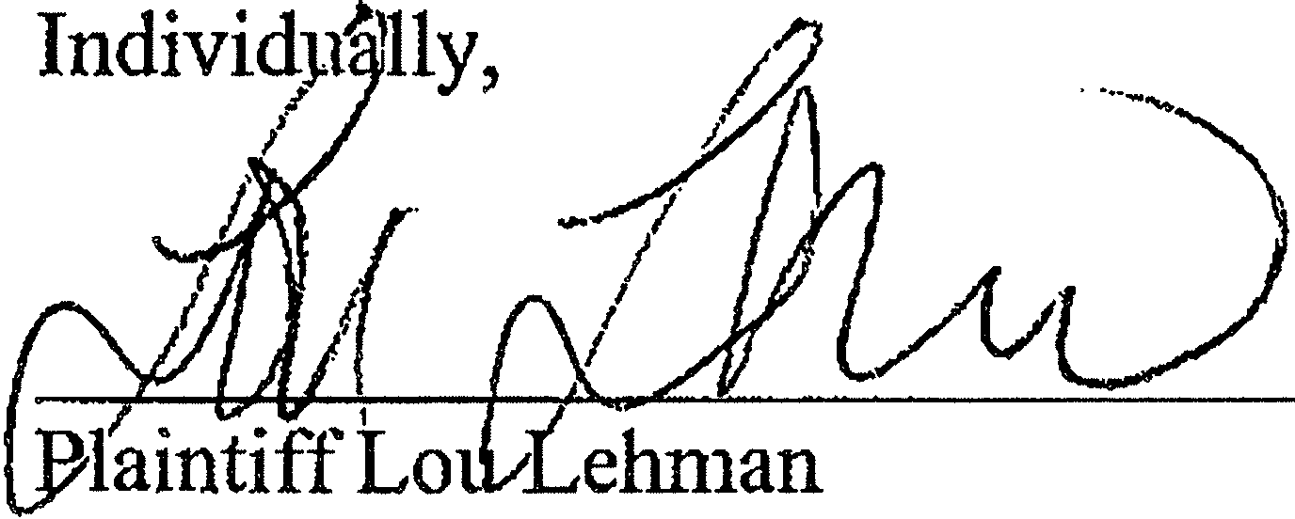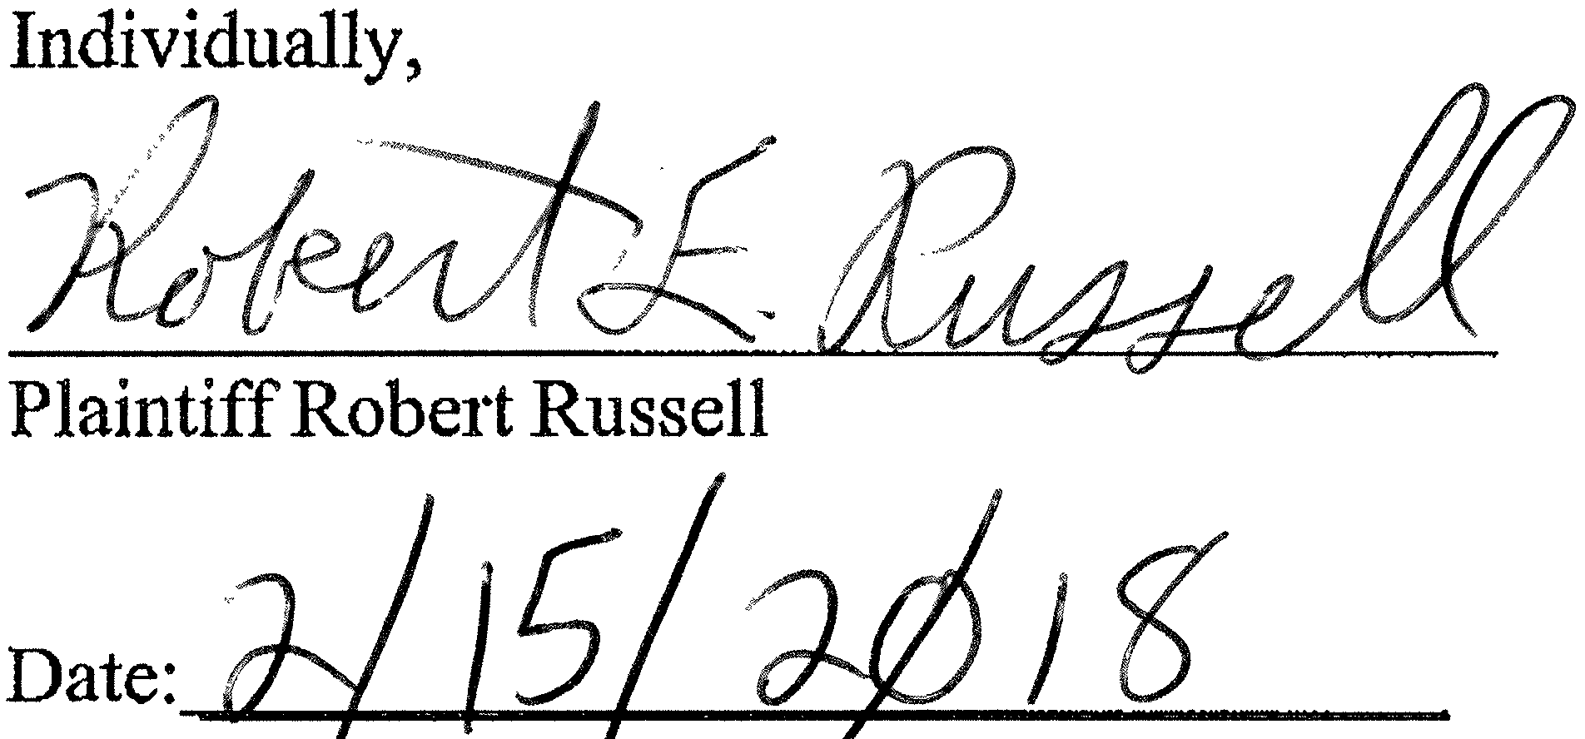IN WITNESS WHEREOF, the undersigned have duly executed this Settlement Agreement as of the date indicated below:

Individually, Individually,

Defendant Michael Vergillo Defendant Kimberly Edwards-Vergillo

Date:
_ Date:. _

DEFENDANT EXTRA CAR AIRPORT PARIGNG, INC.

transfer, or encumber to any person or entity any portion of any liability, claim, demand, action, cause of action, or rights herein released and discharged except as set forth inthis Agreement.

  - Class Signatories. It is agreed that because the Class Members are so numerous, it is impossible or impractical to have them each execute this Settlement Agreement. The Notices will advise all Class Members of the binding nature of the release and such shall have the same force and effect as if this Settlement Agreement were executed by each Class Member.

  - Countemarts. This Settlement Agreement may be executed in counterparts, and when each party has signed and delivered at least one such counterpart, each counterpart shall be deemed an original, and, when taken together with other signed counterparts, shall constitute one Settlement Agreement, which shall be binding upon and effective as to all Parties.

IN WI1NESS WHEREOF, the undersigned have duly executed this Settlement Agreement as of the date indicated below:

Individually, Individually,

Plaintiff Lou Lehman Plaintiff Robert Russell

Date:
_ Date: _

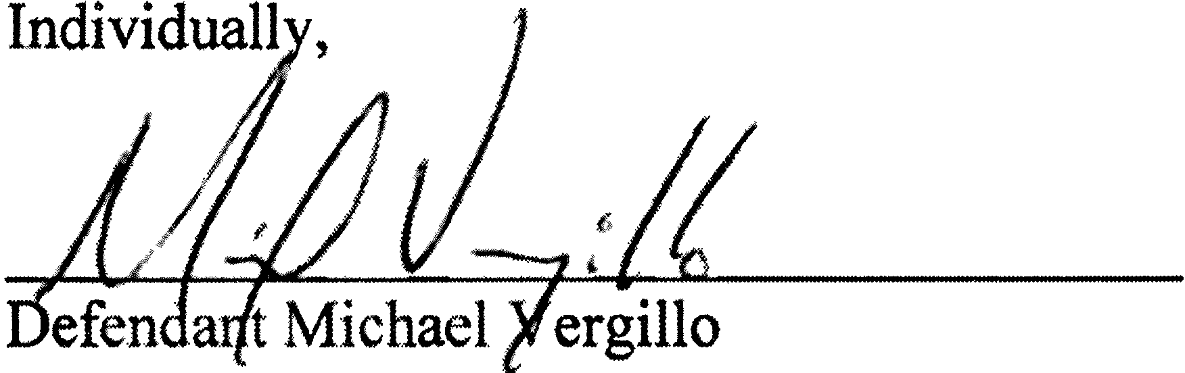Individually,

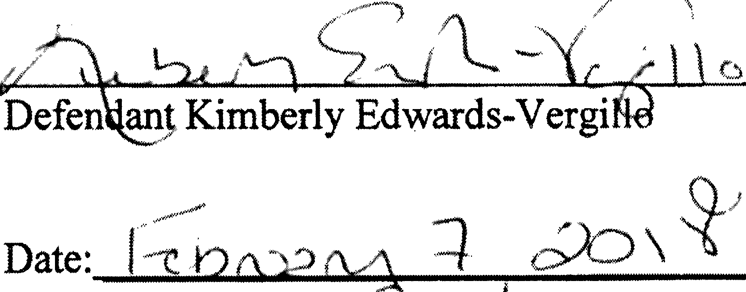//

DEFENDANT EXTRA CAR AIRPORT PARKING, INC.

)/ · r

by: ---Pf.L / U4- L (,.........:J. Gi vz7r/i'-'>L-(\ _

Its:
Cj]-J-'Il=e=$""'-""-t'-'-D"'E;_N---'J;......_ _

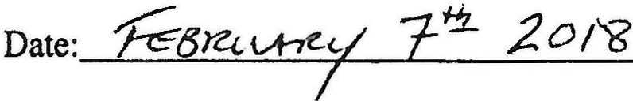

As Defense CoWlSel, ,

.

Date:_"Z/.J;_to (_z_o_l_----

As Class Counsel,

AD 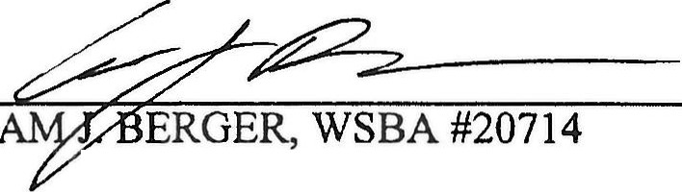

Date:_......;z.'-'A_t6...d..:.....o r.....;_ _

Page 14 of13

